**Question 1.**

**Open the program called Question16A.py from your device.**

Enter your name in the space provided on Line 2.

This is a simple calculator program that can add and subtract two numbers. When this program is run it prompts the user to select addition or subtraction.

The user enters the letter ‘a’ if they wish to add the numbers or enters the letter ‘s’ if they wish to subtract.

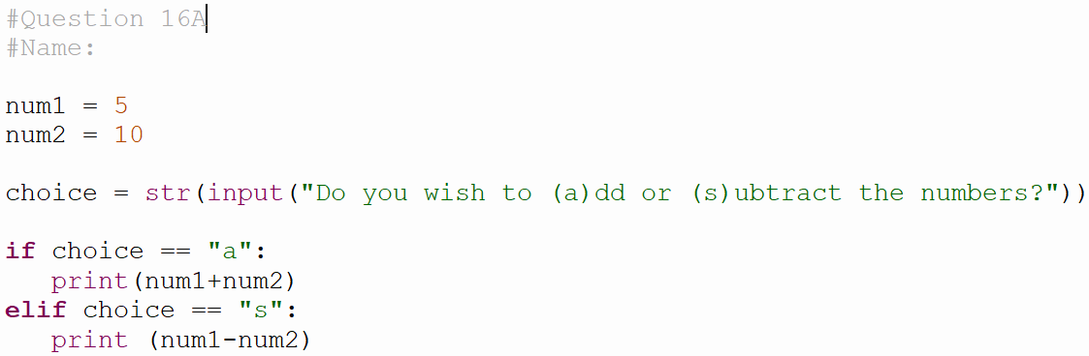

Modify the program to do the following:

1. Add a comment at the start of the program that states ‘This calculator can only add and subtract’. *(4 Marks)*
2. The user should be prompted to enter their name when the program runs. A **suitable variable** should be used to **store the name**: *(4 Marks)*

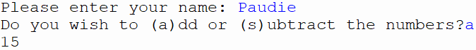

1. The program should **output the following to the screen**, including the **user’s name**: *(4 Marks)*

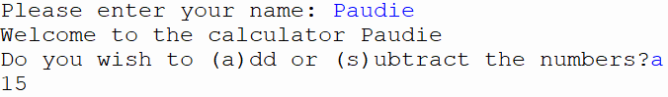

1. The program currently adds or subtracts the two numbers stored in the variables num1 and num2. **Modify** the program so that the **user is asked** to **enter the numbers** that will be added or subtracted: *(4 Marks)*

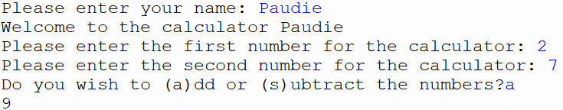

1. Currently the program only displays the answer. In the above example, when addition is selected, the output is: 18

**Modify** the program so that it **outputs the equation and the answer**.

When the program is run the output may look as follows: *(4 Marks)*

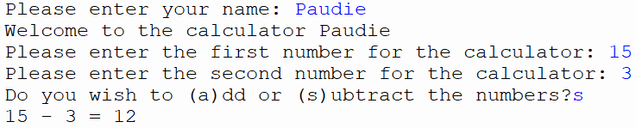

1. The program only works if the user enters a lowercase ‘a’ for addition or a lowercase ‘s’ for subtraction. **Modify** the program so that it will still work if the user enters an **uppercase** ‘A’ for addition or an uppercase ‘S’ for subtraction. *(4 Marks)*

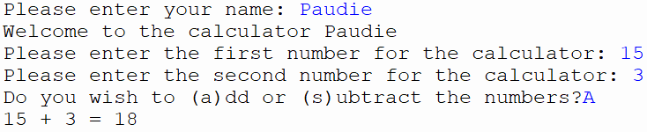

**Question 16B**

**Open the program called Question2.py from your device.**

Enter your name in the space provided on Line 2.

(i) Use comments to describe what is happening in the loop starting on line 5. *(4 Marks)*

(ii) Use the penup() and pendown() commands to remove the diagonal line joining the shapes together. Your drawing should look like the image below. *(4 Marks)*

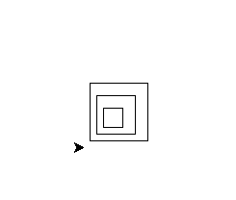

(iii) Modify the code to draw 10 shapes instead of 3. *(4 Marks)*

(iv) Modify the code to draw hexagons (6 sides) instead of squares. *(4 Marks)*